

# SRI LANKA INSTITUTE OF ADVANCED TECHNOLOGICAL EDUCATION

**Higher National Diploma in Information Technology**

HNDIT 2404

Project (Individual)

Supervisor: Ms. P.G.R.N.J Gamlath

**POINT OF SALES MANAGEMENT SYSTEM FOR**

**ASIAN DISTRIBUTORS**

**Project Proposal**

|  |  |  |
| --- | --- | --- |
| **Name of the student** | **Register Number** | **Signature** |
| M.N.F Yumna | KUR/IT/2020/F/0045 |  |

**Academic Year: 2020/2021** **Year-II, Semester II**

(Submission date-2020/03/26)

**Table of Contents**

**1 Introduction 3**

**2 Background and Motivation 4**

**3 Problems in Brief 4**

**4 Aims and Objectives 5**

**5 Proposed solution 6**

**6 Resources Requirements 7**

**7 Gantt Chart 8**

# Introduction

The project proposal is submitted to meet software development requirements of the individual project module conduct by the Sri Lanka institute of advanced technological Education. (SLIATE)

The Asian Distributors is managed by M.Z.M. Shahlan. They are currently involved in sales of mobile and accessories etc. Apart from main shop, Currently the Asian Distributors use a manual system that monitors the salary and stock that is been recorded in a book that needs to be maintain frequently. The Asian Distributors doesn't have a proper method to calculate balance and income of goods. Since the documentation is managed manually it error prone and waste time therefore the system is properly needed to organize the data because it is a risk to keep the data without any security measures as it can be stolen/destroy. Mainly this project is created to the system that calculates profits, finding the routes located and stock inventory as a record.

# Background and Motivation

The Asian Distributors are in a small chain Managed by M.Z.M. Shahlan. They are currently involved in sales of mobile and accessories etc. This will provide an insight to the current option of the client requirements analysis, design and implementation of propose system. It the testing method and test case of the system. lastly future enhancements that could be done as a system.

# Problems in Brief

As a current The Asian Distributors is used manually on record books that need to be managed therefore, we use a method error prone free and waste time therefore we come upon a system which would manage all the records in to one system frequently.

# Aims and Objectives

Client can manage his business easily and reliably. By looking at the profit that he can generate through the system, he can feel relaxed. Therefore, the main objective of our projects is to develop a system for stock handling, payroll, route located and balance and income calculation for our company.

.

* There's an interface to view manage and generate report.
* There should be a password protected access.
* There's an interface being recorded on transactions.
* Must have an interface to manage cash receipts for goods.
* Sales and inventory should be recorded.
* There are routes to manage/access branches.
* There should be a user-friendly interface that is easily accessible.

# Proposed solution

Are project here by a solution to maintain the business and keep it upgraded in a successful manner.

With the proposed system we get information on inventories sales as a record. So that the client can generate, and analyst detailed reports on current and past transaction, payments, sales, routes located and etc. Through this system client can perform and take the necessary steps in order to prove the business and client frequently.

In our The Asian Distributors system we maintain three main functions as,

* Repair-receive date, received shop, phone model, issues, receive only the phone or as a whole unit and return date.
* Stock-brand, model, quantity, cost, selling price
* Route- this distributes to many locations that have been sold out to the particular shop and that shop displays all the details as balance-income, last order-amount and order history.

# Resources Requirements

* 1. Hardware Requirement
* RAM 1GB or more
* Android mobile or tablet
* Java installed PC
  1. Software Requirement
* Windows/mac
* SQLite
* Android studio IDE
* Android system version 4+
  1. Languages
* XML
* JavaScript

# Gantt Chart

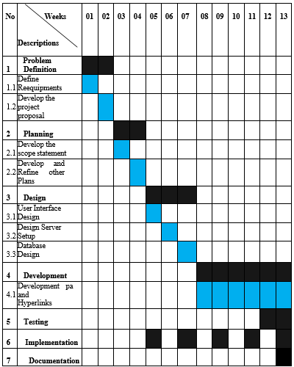

**8. Client Details**

* Client Name - M.Z.M. Shahlan.
* Address – 531/4, Bandawa, Polgahawela.
* Contact No - 0771454960

**8.References**

Android studio basic Tutorial

<https://youtu.be/r5fQScR37OI>

Android studio Tutorial

<https://youtu.be/4w2jHFSP9IE>

W3school - Java Tutorial

<https://www.w3school.com>

W3school - Java Tutorial

https:/[/www.ude](http://www.udemy.com/course/javascript-bootstrap-php-certification-for-beginners/)m[y.com/course/javascript-bootstrap-php-certification-for-beginners/](http://www.udemy.com/course/javascript-bootstrap-php-certification-for-beginners/)

9. Declaration of the supervisor

I hereby accept the proposal of this project and permit the student to launch this project.

……………………………………. …………………………………….

(Date) (Supervisor’s signature)